Welcome to Trinity Art Gallery!
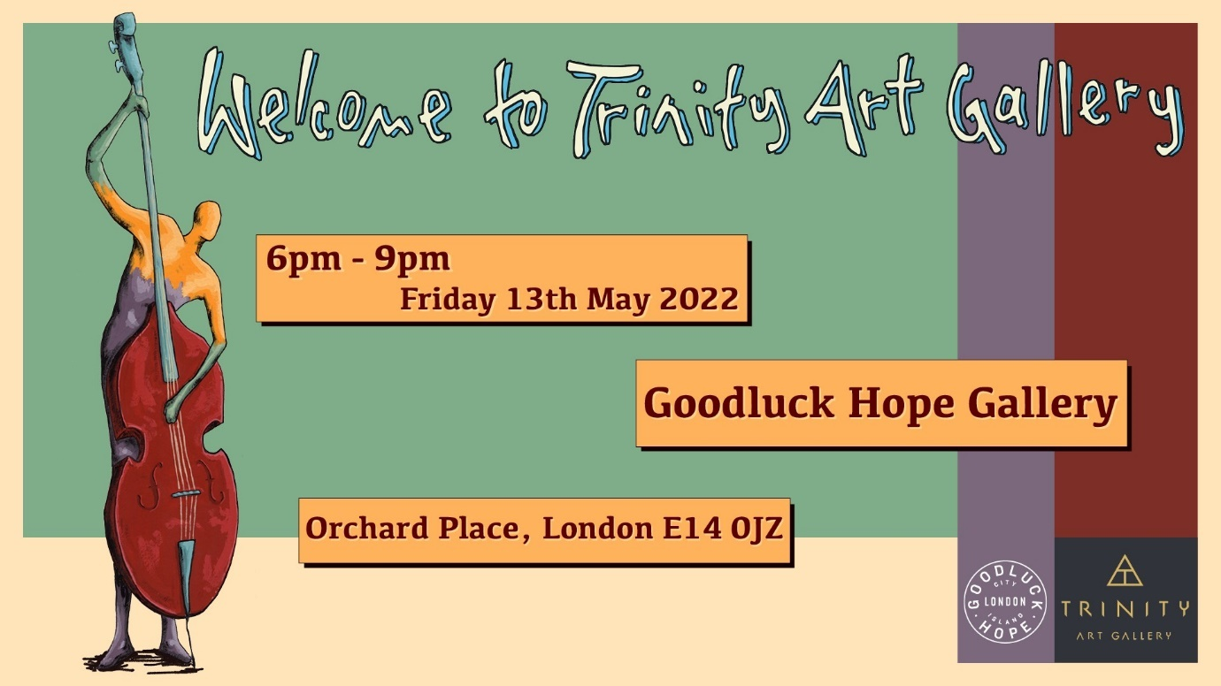

Join us to celebrate music, art and life at the grand opening of Trinity Art Gallery at Goodluck Hope!
Following 4 wonderful years at nearby London City Island, we’ll be marking this exciting new chapter by hosting a celebration evening. We’ll have live classical music performances from Arcangelo Orchestra, as well as contemporary acoustic sets provided by Sirlute. Alongside these musical treats will be many of the gallery’s painters, sculptors and ceramicists who will be exhibiting their latest work.

Schedule:
6.00pm: Doors open, drink reception begins and background music via DJ.
7.00pm: Welcome introduction by Trinity Art Gallery owner and local artist Ian Felton, followed by a series of music performances and art presentations including
8.00pm: Drinks and DJ music resume
9.00pm: Close

Come along on Friday 13th May from 6-9PM to explore the new gallery, celebrate with friends and enjoy a glass of fizz!

Register for your free place here:
https://www.eventbrite.co.uk/e/welcome-to-goodluck-hope-tickets-321303205537

- ENDS –

Notes for Editor
PROVISIONAL SCHEDULE - THIS MAY BE ADJUSTED – DO NOT SHARE WITH PUBLIC
6.00pm: Doors open. Drinks and background music, via DJ.
7.00pm: Presentations with live music performances:
7.00pm: Welcome and introduction to Trinity Art Gallery at Goodluck Hope from the host Ian Felton (gallery owner and local based artist)
7.05pm: Introduction to JR & Sirlute. First music act: 2 songs, time approx. 7/8 minutes.
7.15pm: Introduction to fine artist; Cat Vitebsky (TBC) a sculptor who’s latest work is a piece commissioned by Sean Mulryan and will be unveiled on 13th prior to it becoming a public art piece in the sculpture garden at London City Island.
7.18pm: Introduction to a new ceramic artist to the gallery.
7.20pm: back over to JR and our second live music act from Sirlute. Two live songs – approx. 7/8 minutes.
7.28pm: Introduction to the artist Vincenzo Muratore (another favourite of Sean’s) and unveiling of his new work.
Further introductions and acknowledgements to other fine artists in attendance.
7.35pm: Introduction and short conversation with Jonathan Coen.
First sonata performed by Arcangelo – approx. 10 minutes. Harpsichord & Violin.
7.47pm: Introduction to Sean Mulryan and Ballymore, a few words to acknowledge the development of Goodluck Hope and collaboration with Trinity Art Gallery and Studio. A toast to Goodluck Hope.
7.50pm: Second sonata performed by Jonathan Coen and Arcangelo.
8.00pm: Performances finish. DJ takes over to play more music while visitors gradually disperse.
9.00pm: Gallery closes.

About Trinity Art Gallery
Address: 79 Orchard Pl, London E14 0JU
Instagram – @trinityart.gallery
Website - https://www.trinityart.gallery/
Twitter - @TrinityArt_

Contact: info@trinityart.gallery
Creative Director - Ian@trinityart.gallery
Assistant Manager - remi@trinityart.gallery
Communications & Content Creator - Amelia@trinityart.gallery
Art Technician and Logistics - sam@trinityart.gallery

About the Artists
Welcome to Goodluck Hope will feature over 20 artists’ work, including:
Painters
- Noel Paine
- Marilyn Durkin
- Ian Robert Felton
- Sarah Ray Dobson
- Glory Samjolly
- Triana De Llamo
- Preslav Kostov
- Rita Krupaviciute
Sculptors
- Vincenzo Muratore
- Cat Vitebsky
- Eva Terzoni
- Nhung Ha
- Jim Jack
- Roli Ross
Illustrators
- Max MK
- Peter Sulo
Ceramicists
- Jane Cairns
- Talia James
- Ronaldo Wiltshire
- Helena Lacy
- Remi Russo

About Arcangelo
Arcangelo on London City Island
It started one evening in early 2019 when Arcangelo’s Artistic Director and London City Island resident Jonathan Cohen was out for a stroll and found his eye drawn to the sight of someone working inside the brightly-lit art gallery. He’d been interested by the space since he’d moved to the island some months before as it looked like it could be perfect for music. Maybe the busy person inside could spare a moment to let him know more, or who to ask? Shortly afterwards, Jonathan was inside and chatting to Ian Felton…
…three years later, it’s impossible to imagine Arcangelo’s recent life without Trinity Art Gallery and Ian’s friendly support. For it turned out that the space was not only ideal for music, but one into which it was positively welcome. And so numerous Arcangelo concert projects were rehearsed in a uniquely creative environment that quickly won favour with our contributing musicians from the UK and around the world for its bright spaciousness, clear acoustic, and ever-changing visual stimulus. Those projects then went onto the concert stage at Wigmore Hall in London and venues across Europe, and into the recording studio. Music first rehearsed at Trinity Art Gallery is now streaming around the world on Spotify.
We will also be forever grateful to Ian and Trinity Art Gallery for their support with another true legacy project at a most difficult time. During lockdown, we were desperate to find a way to continue providing training for members of our young artist programme – but all of our scheduled activities had collapsed. Once again, a tentative question to Ian met with a friendly, supportive reply. Of course! And in the midst of lockdown, once again, the gallery became our safe space as we convened four days of academy sessions for our young musicians with leading teachers, making positive use of the strange time-void with jam-packed sessions on repertoire, instrumentation, accompaniment. It’s all pretty esoteric stuff to a layman, but we can assure you it’s the water of life to young musicians whose development would otherwise have suffered disastrous interruption. You can see what it meant to them in the video diaries posted on our YouTube channel, and watch their graduation concert at Wigmore Hall on 12 July.
From the start we knew that Ian and the gallery were offering so much more than a space – and Ian also knew that Arcangelo could be so much more than a visitor. And so we immediately collaborated on open rehearsals, inviting our respective supporters to share the familiar and the new over some 10 sessions in total. And in early 2020, memorably, we collaborated on an evening of art and music with performances by Arcangelo and presentations by artists Jim Jack and Noel Paine – all MCed, of course, by Ian.
Artists are nomads and so we always knew that at some point it would be time to pack up our tents and steal silently away from Trinity Art Gallery. We hope that those who use the space next will also find it a place of creative renewal, and we challenge them to make their activities resonate as far as ours did! We thank Ian, Trinity Art Gallery, and Ballymore for what has been as the great song says “a brief episode” – memorable, cherishable and sustaining.
Friendships, of course, endure, and Jonathan and Ian are still chatting…
Here’s to the future!
Julian Forbes, Arcangelo General Manager, April 2022
Instagram – archangelomusic
Twitter - @ArcangeloTeam

About Sirlute
Sirlute provide musical opportunities for young people, in the hopes that they can create positive behaviour and give back to the community through specialised programmes. Sirlute is determined to create an inclusive, non-judgmental safe space that supports young people to be the best that they can be, regardless of where they are from.
The acts that will be showcased at Welcome to Goodluck Hope are Musatu and Norika, two young performers with a lot of talent.
Norika is a neo-soul and UK R&B singer/songwriter with an Albanian heritage but born and raised in north west London. Her single ‘Talk About US’ is on all streaming platforms and she has performed many live gigs including performances with GRL GNG in Boxpark Shoreditch and Wembley. Norika is planning to release another live session and more music in the near future. You can find out more information on future releases and gigs on her Instagram.
Southeast London musician, Musa2, enters the music scene with her ethereal vocals and production, inspired by her surroundings and experiences. She serves a melting-pot of culture and creativity with her touches of Neo-soul, Hip-Hop, Afro Alté, as well as poetry. Aiming to inspire creatives to bring out their authenticity, allow the sounds of Musa2 to take you on a spiritual and cultural experience, reminding you of your abundant artistry.
Norika
Instagram - N0rikaa
Musa2
Instagram - mela_musa2
Twitter - @mela_musa2
Soundcloud
About Goodluck Hope
For further images or information on Goodluck Hope please contact:

The Communication Group plc
Goodluckhope@thecommunicationgroup.co.uk
020 7630 1411

For sales enquiries, please visit www.goodluckhope.com or call 0203 944 1825
Encircled by water, Goodluck Hope is a new riverside neighbourhood in East London, comprising 804 new homes. Adjacent to London City Island, the cultural island community home to English National Ballet, Goodluck Hope is a short walk to Canning Town station across a pedestrian footbridge, and benefits from excellent connectivity, world-class amenities and a tranquil, waterfront lifestyle offering.

Goodluck Hope is developed by Ballymore, one of Europe’s leading property developers synonymous with great design, architecture and regeneration and with a reputation for innovative projects that push boundaries and energise cities.

https://we.tl/t-kRjV1F1uzG - Artist photos

